Standby Pulse Rate Adjustment

This document will provide a baseline for adjusting the Standby Pulse Rate when a site must go into backup pulse.

Backup pulse is an artificial pulse that we set based on what conveyor speed we want to run the belt at. It is the time measured between each pulse.

We are trying to mimic, as close as possible, the pulse rate when the belt runs at certain speeds. This should get us to fairly accurate timing of all functions throughout the wash.

Adjusting Standby Pulse Rate:

1. Change Pulse Sensor Choice to 3 as seen below:

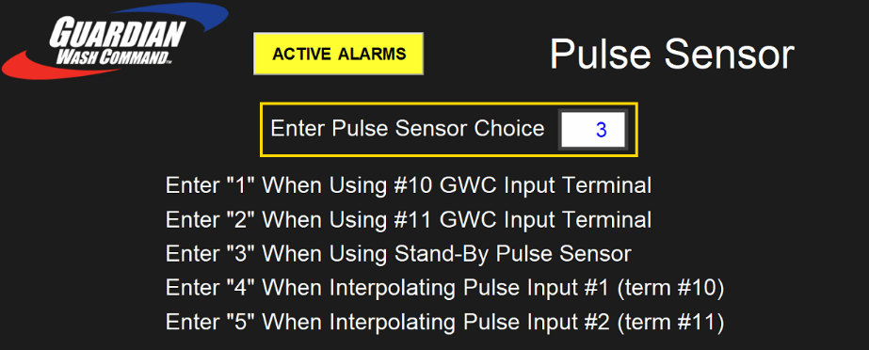

1. Then change Standby Pulse Rate in this box as seen below:



**Conveyor Speed to Pulse Rate Conversion Chart**

|  |  |  |  |  |  |  |  |
| --- | --- | --- | --- | --- | --- | --- | --- |
| Conveyor Speed (Hz) | 70 | 65 | 60 | 55 | 50 | 45 | 40 |
| Standby Pulse Rate | .310 | .330 | .360 | .390 | .435 | .485 | .548 |

*Note: These settings are standard for Tommy’s 8 Flag pulse collar & 17 tooth sprockets.*

Minor adjustments may still be needed after inputting these settings. Follow adjustment guide below:

* If functions are turning on too late, the pulse rate needs to be decreased.
* If functions are turning on too early, the pulse rate needs to be increased.