How to Setup Date and Time

- Click on the “Setup Menu” button
- Click on the word “Menu” in the upper right of the page this will bring you to an “Advance Setup Menu
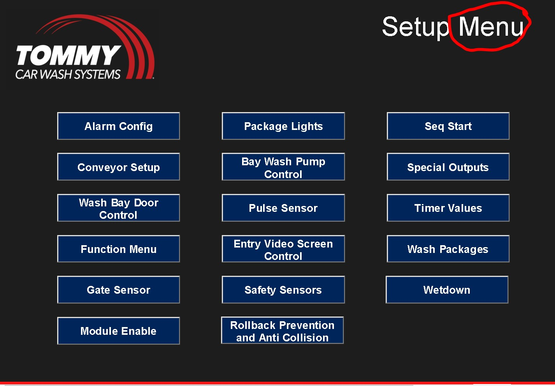

- In the “Advanced Setup Menu” adjust the time and date on the screen to the appropriate time and date, using military formatting.
a. Example: in the hour field 3pm = 15
