**GV Eye Setup**

This document covers the adding of cameras into the GV Eye mobile app for GeoVision systems.

Please obtain a copy of GV Eye from the Google Play store or the Apple App store.

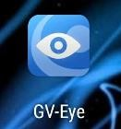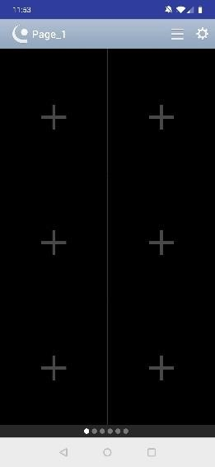

When the app

opens, tap

the

menu in the upper

right corner.

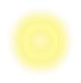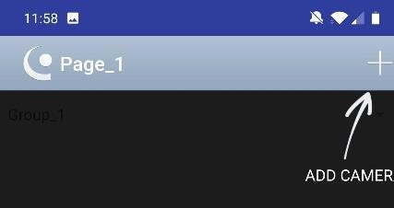

After

installing G

V

Eye,

tap the

icon to

launch the app.

Tap the

+ sign.

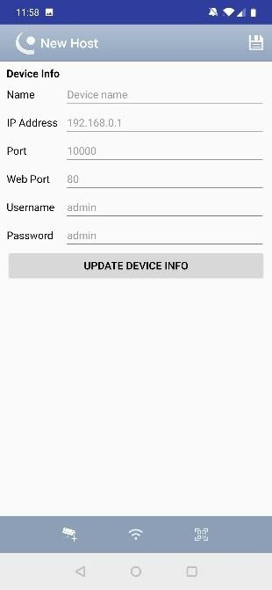

Fill in all fields

and tap

“

Update

Device Info.

”