Entrance Module Controller Troubleshooting
Tommy Car Wash Systems

The Entrance module system is controlled by 2 programs, InstaCal and Tracker Images, operating on a Kangaroo Mini PC which is in turn connected to a blue controller box. On occasion, configuration problems in the system may result Tracker Images displaying the following error messages: “Cannot find CB.CFG File” “ULStat 126”. Following this, Tracker images will display a blank screen in place of the proper loading instructions.
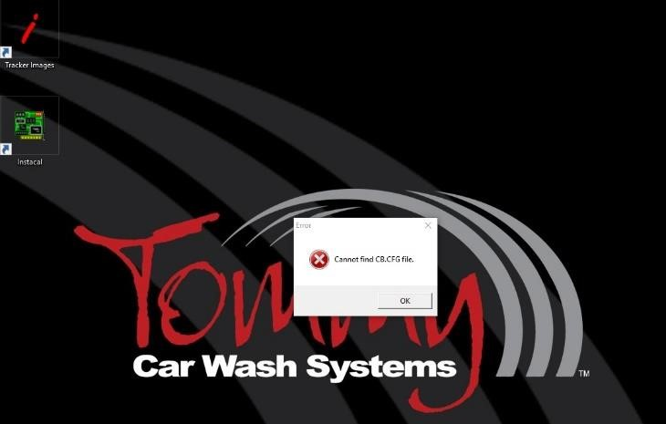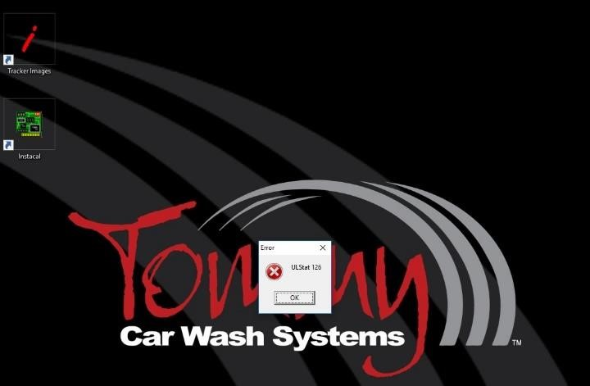

To resolve this error, close Tracker Images and open InstaCal from the desktop. InstaCal will then display the “System Modifications Required” window shown below. 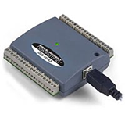
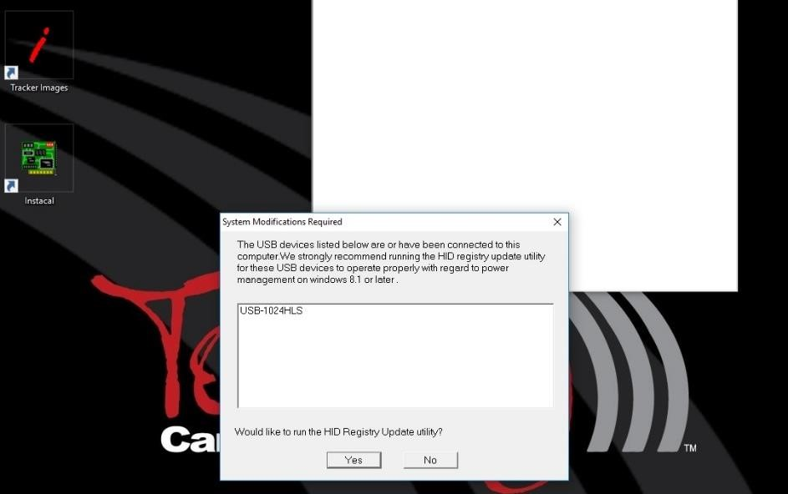
Select YES to run the HID Registry Update utility and then select UPDATE.
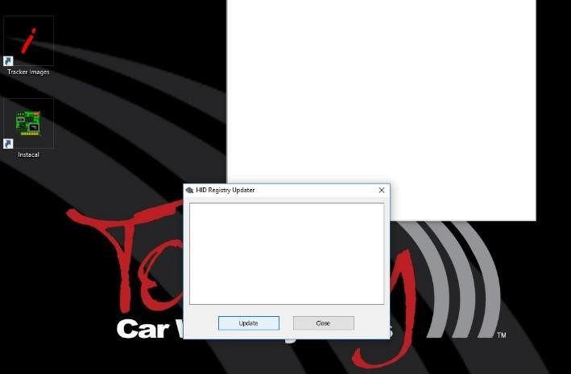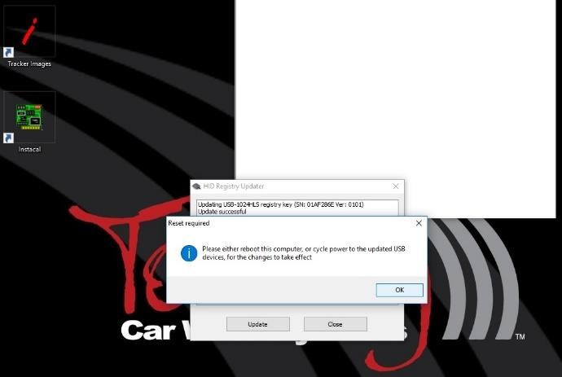

InstaCal will prompt you to reset the updated USB devices. To do this, select OK and then turn off the computer by selecting the button in the bottom left hand corner of the desktop followed by POWER and SHUT DOWN).
Unplug the blue box USB cable from the computer, plug it back in, and finally turn the computer back on using the external power button.

When the computer has restarted open InstaCal from the desktop. The system will report that Plug and Play devices have been detected. Select the new USB device using the checkmark box and then select OK to continue.
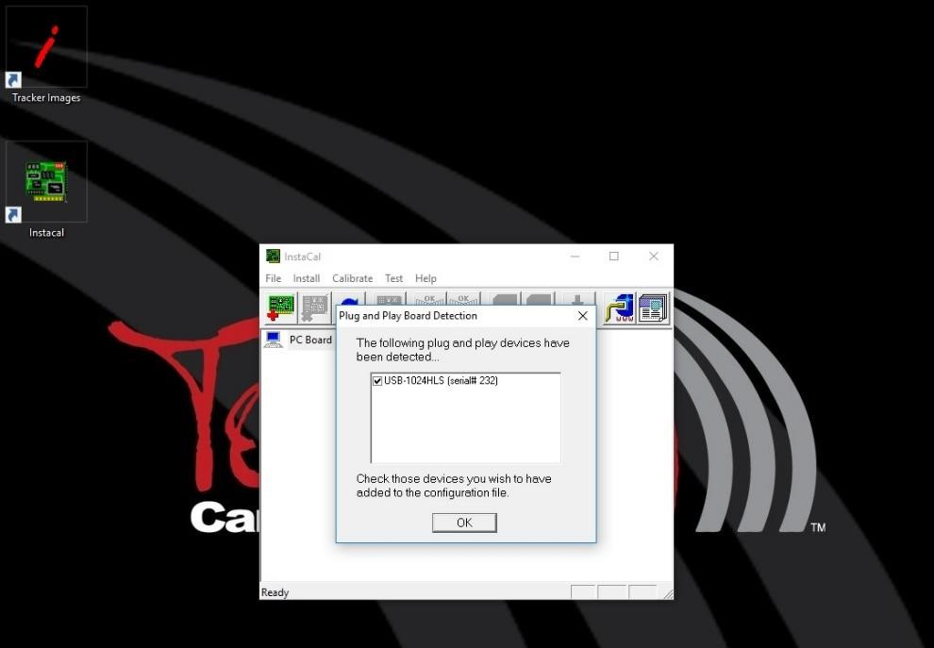

Right click on the new device underneath “Universal Serial Bus”, aka “USB” and select TEST then DIGITAL.
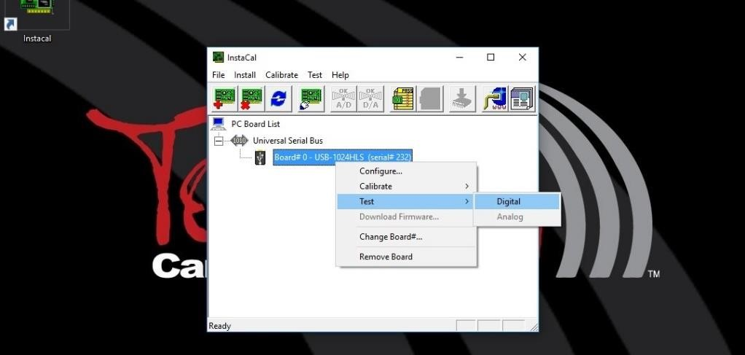
Select TEST and wait for all Pass icons to turn green. Select OK to continue.
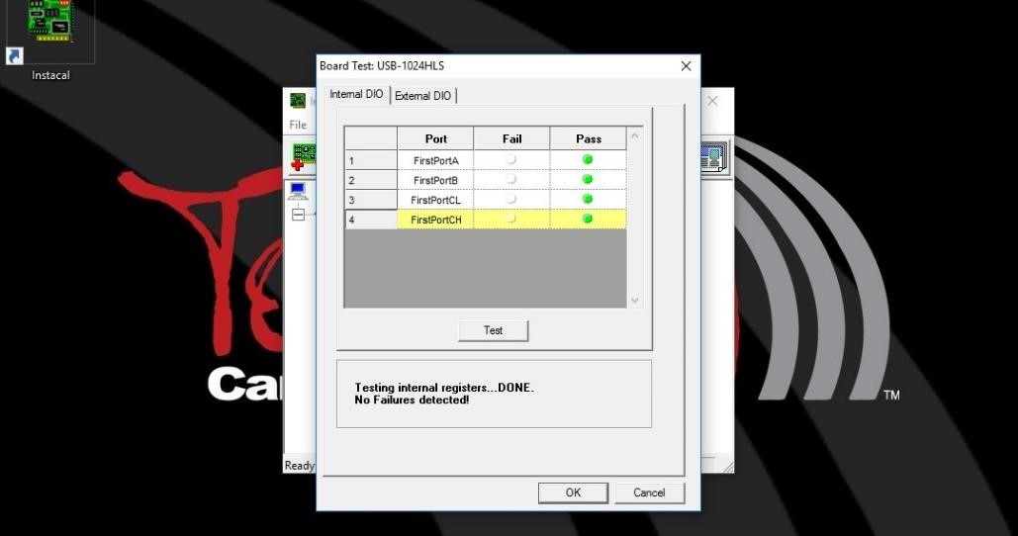
Open Tracker Images. If the program correctly displays loading instructions, your entrance module has been properly configured and is ready to use. If not, select TOOLS and MACHINE CONTROLLED from the Tracker Images top menu to finalize your configuration.
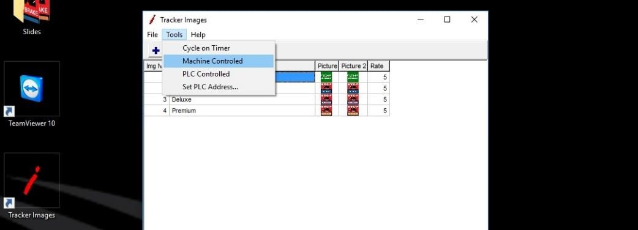 Prepared 6.22.2016

