Only one iPad being able to log in at a time

Concern:
Customer calls and has issues where they are only able to connect 1 iPad at a time without it logging the other iPad off.

Fix:
When this happens first verify, they have RD client usernames setup properly ie: View1 and View2 and View 3. We do not want any RD applications to use the same username. After verifying that if problem still exist re install “UniversalTermsrvPatch_20090425”
Open my computer and go to the “CCS” folder
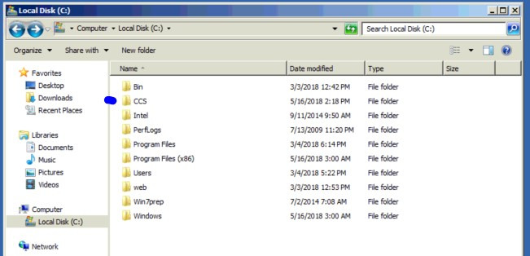

Open “HMI-Server Setup-Files” folder
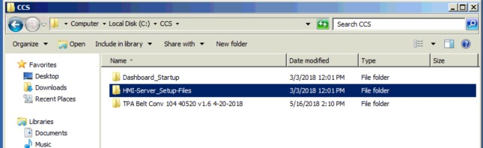
Open “UniversalTermsrvPatch_20090425” folder
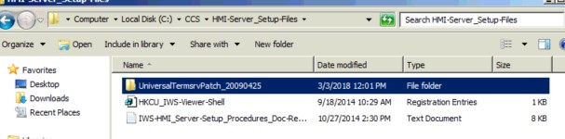
Open “UniversalTermsrvPatch-x64”
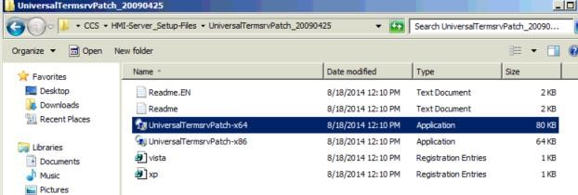

If this is the problem, you will notice it says under “patched” “no”
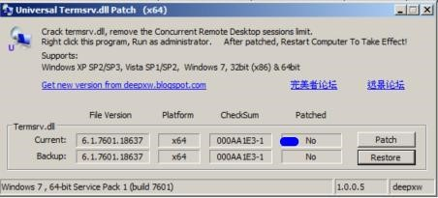

Click on “Patch” and follow instructions and it will make you reset computer
