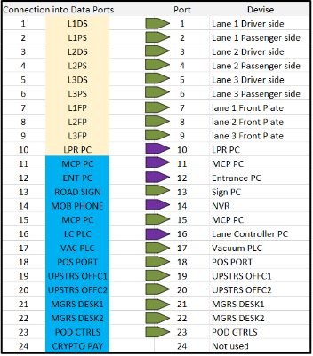

Ports 7,8,9 for the Front License Plate Cameras are Optional and may not be used.

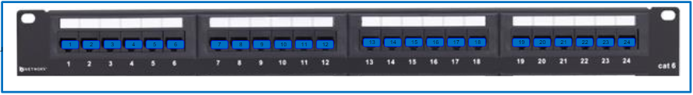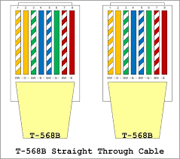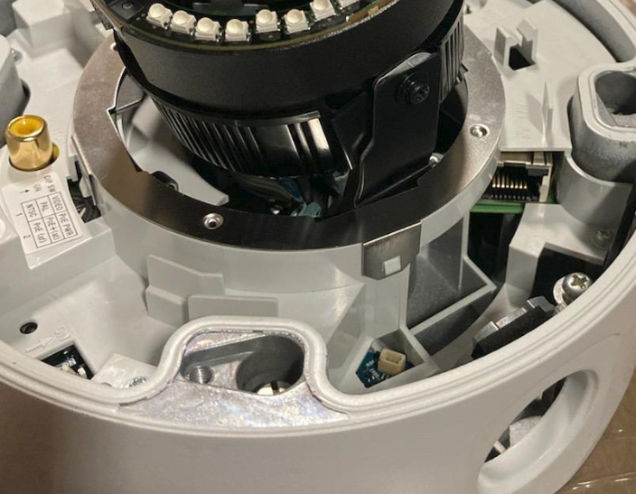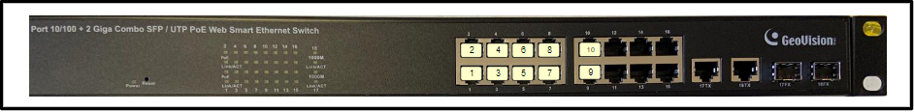

Cat 5/6 Ethernet ends will use the B standard on both the switch side, and the camera side.