Configuration steps for GeoVision Edge Recorder
- Download GV Edge Recording Manager from GeoVision’s website (http://www.geovision.com.tw/products.php?c1=14 – click on URL and scroll down until you see GV- Edge Recording Manager)

- Install the software once its downloaded and open it up (recommend making a desktop shortcut)
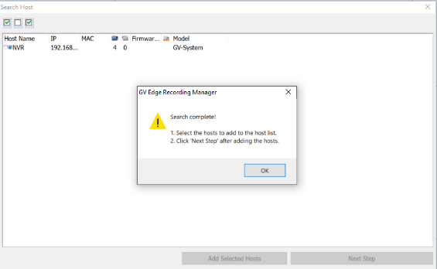
- On initial setup, 2 boxes will pop up once the software loads, close out of both. The boxes that will be closed can be seen by the picture to the right.

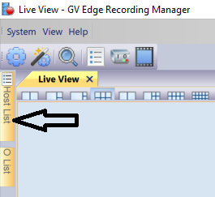
- Once those boxes are closed look for the “Host List” button on the left side of the screen. It is shown by the black arrow in the picture on the right.

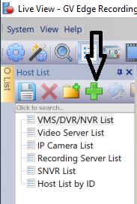
- Next, click on the green + symbol that is pointed out by the arrow on the right.
- Select the option “Add VMS/DVR/NVR”, this will open a new dialog box

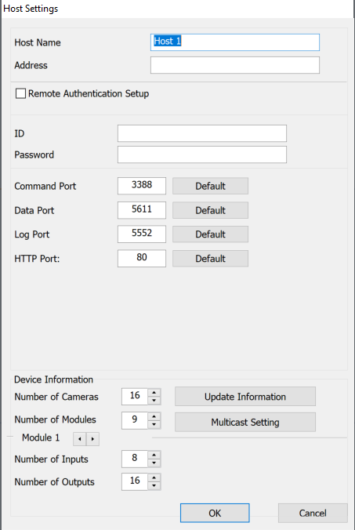
- The box that opens should be the same as the picture on the right.
- Host Name – Name of DVR that will appear in GV Edge Recording Manager
- Address – IP address of DVR. If device with Edge IS NOT on the same network as the DVR, the external static IP of the sites modem will be used here. (go to ipchicken.com to view external static IP or call your ISP) If device with Edge IS on the same network as DVR then the address would be 192.168.25.99 (Note that the Edge device will need an IP of 192.168.25.X)
- ID/Password – Login credentials of the account that was created in GV-VMS.
- Click OK and the list on the left should populate with cameras that are connected to the DVR
- Click and drag the cameras to a windowed pane to view camera footage.

