Remote Viewlog Initial Config Setup
- Download RemoteViewlog V2 from GeoVision’s website (http://www.geovision.com.tw/download/product/ - Click on URL, click on Video Management Software, scroll down until you see Remote Viewlog V2)
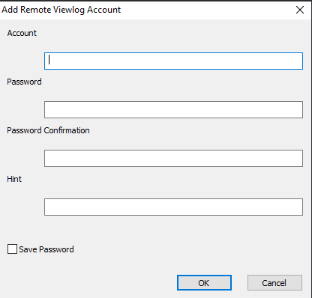
- Install the software (recommend making a desktop shortcut) and load it up once its finished. It will prompt you to make an account to use the software, the page that loads up should be similar to the picture on the left (recommend using the same info as the GV-VMS software)

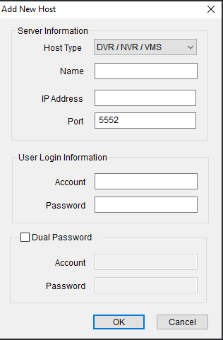
- After an account is made, a new page will appear prompting you to add a new host. It should be like the picture on the left.
- Name – name of the DVR that you are attempting to connect to (enter in what you would like to see in Remote Viewlog when pulling video)
- IP Address – If device being used IS NOT connected to the Camera Network, then the sites external static IP address would go here. (go to any web browser and type in ipchicken.com to see what your static IP is). If device being used IS connected to the Camera Network, then the device must use an IP address of 192.168.25.X to view recorded footage.
- Account/Password – Login credentials of the account that was created with the GV-VMS software
- Click OK when finished

- The sidebar in Remote Viewlog should then populate with the cameras that are on the DVR. Click and drag the desired camera into a windowed pane to begin viewing video footage.

